# Apply filters to SQL queries

## Project description

In this project, I will demonstrate basic SQL filters to help the given company with security related issues like checking suspicious log entries and providing information for device update requests.

## Retrieve after hours failed login attempts

In this task there was a potential security incident after 18:00. The request was that I investigate all failed login attempts made after that time.

The following code demonstrates the SQL query I made to investigate the logs.

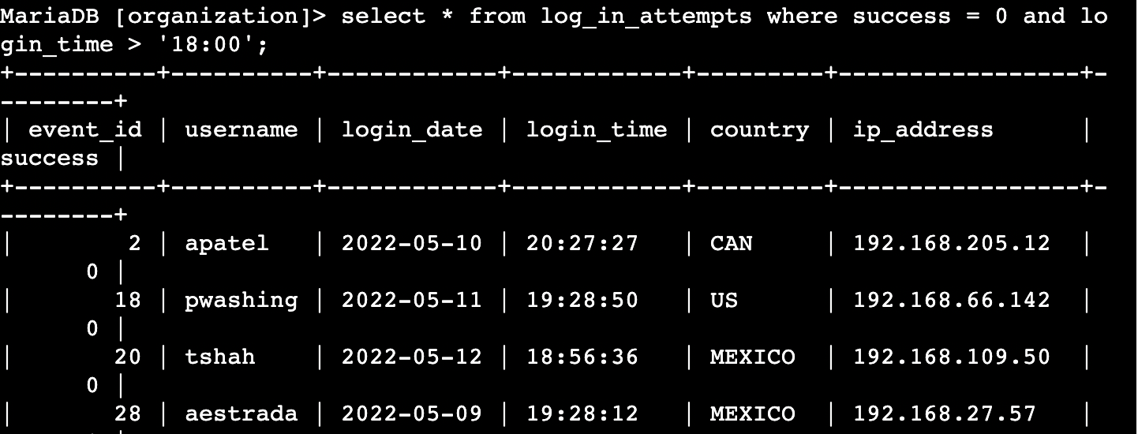

First I selected all data from the log_in_attempts table.  
After that I used the WHERE clause AND the and operator to filter my results on failed login attempts that occurred after 18:00.

‘success = 0’ refers to failed login attempts and bracket between login_time and 18:00 means to filter before that time.

## Retrieve login attempts on specific dates

A suspicious login attempt was made on the date: 2022-05-09. The request was that I investigate all login activity that day, including the day before.

The following code demonstrates the SQL query made to investigate the logs on the given days.

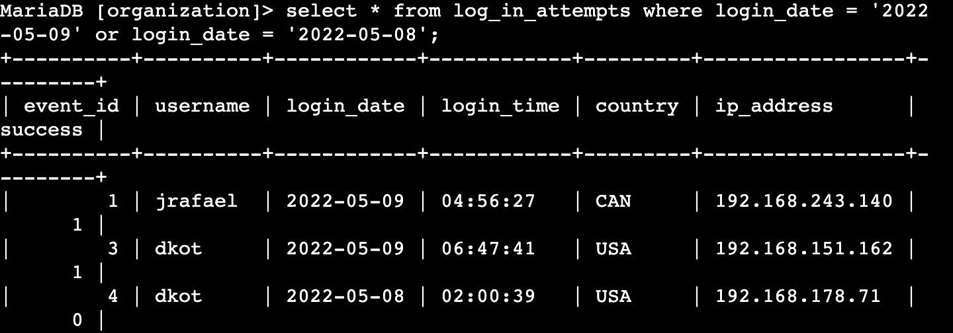

First I selected all data from the log_in_attempts_table.

After that I used the WHERE clause and the OR operator to filter my output to only the date 2022-05-08 and 2022-05-09.

## Retrieve login attempts outside of Mexico

In this task I was told that suspicious login activity was detected and also that it’s certain that it’s outside of Mexico.

The following code demonstrates the SQL query I made to filter the login attempts outside of mexico.

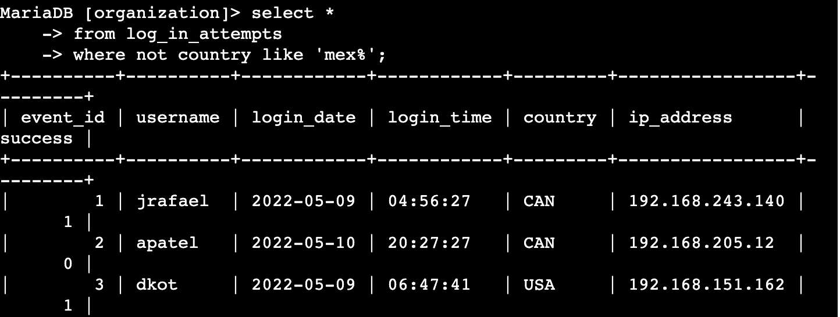

First I selected all data from the log_in_attempts table.

After that I used the WHERE clause and NOT operator to filter out login attempts outside of mexico. I also used the LIKE operator with ‘Mex%’ to filter out every data starting with Mex.

The % represents, in this case, that any amount and type of character can be after the word ‘mex’.

## Retrieve employees in Marketing

In this task there was an update request for certain computers. I had to provide information about the desired devices.

This SQL query demonstrates the code I made to filter out the devices.

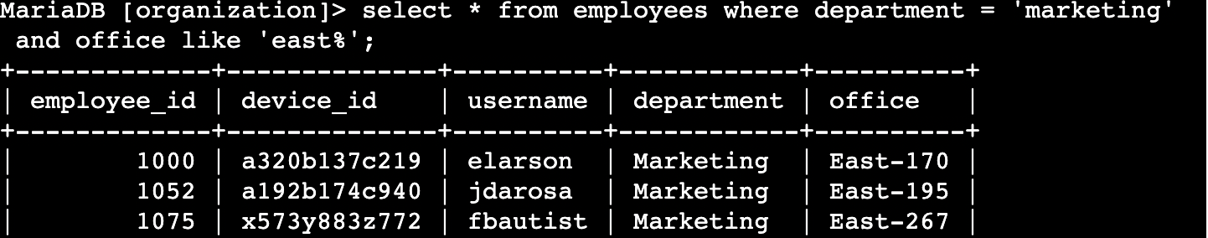

First I selected all data from the employees table.

After that I used the WHERE clause with AND to filter out every type of East offices at the Marketing department.

The “office LIKE ‘East%’ ” line represents this.

## Retrieve employees in Finance or Sales

The devices from the Sales and Marketing department also needed an update.

Since this was a different kind of security update, I had to filter out only these two departments

The following SQL query demonstrates the code I used for this task.

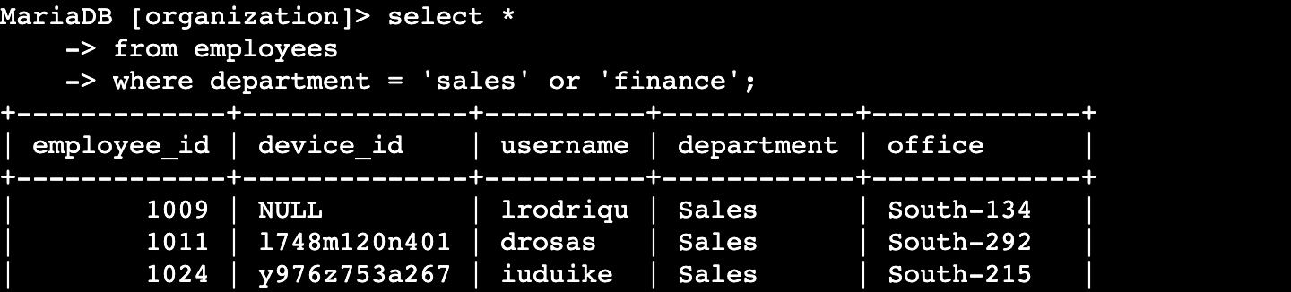

First I selected all employees from the employees table.

After that I used the WHERE clause with OR to filter out employees in the Finance and Sales department.

I used OR instead of AND because I want the list of all employees working in those two departments.

## Retrieve all employees not in IT

In this task, a security update was also requested, this time it was everyone excluding the IT department.

The following SQL query demonstrates the code I made to filter this out.

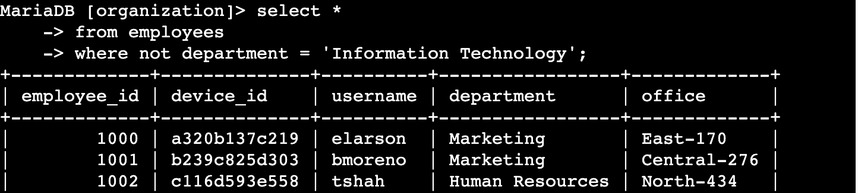

First I selected all employees from the employees table.

After that I used the WHERE clause and the NOT operator to filter out every department outside of the IT department.

## Summary

In this project I applied different types of filters to SQL queries to help me get specific kinds of information from the database.

I used two different kinds of tables to draw information from.  
I also used AND, OR, NOT, operators to help me get specific information.

On top of that I used LIKE and the (%) wildcard to help me filter for patterns.